Yaadhum — Complete Backend Logic

Eight real CBSE 2026 papers, the full pipeline, and how tiers are decided

1. The consolidated corpus
Eight papers now measured. Every structural axis has at least two values, which is the argument for discovering everything per paper rather than hardcoding per subject.
# | Subject | Code | PDF pp | Logical pp | Text layer | Imposition | Rotation | Languages | Sections
1 | English Lang. & Lit. | 2/7/3 | 19 | 19 | Yes, clean | 1-up | 0° | English | 3
2 | Science (V.I.) | 31(B) | 27 | 27 | Yes | 1-up | 0° | Bilingual | 3 = disciplines
3 | Social Science | 32/7/1 | 27 | 27 | Partial | 1-up | 0° | Bilingual | 4 = sub-subjects
4 | Mathematics Std | 30/7/1 | 7 | 27 | None (vector) | 4-up | 0° | Bilingual | 5
5 | Mathematics Std | 30(B) | 6 | 23 | None (vector) | 4-up | 0° | Bilingual | 5
6 | Hindi Course B | 4/8/3 | 16 | 16 | None (vector) | 1-up | 0° | Hindi | 4
7 | Hindi Course B | 4/7/2 | 11 | 11 | None (vector) | 1-up | 0° | Hindi | 4
8 | Tamil | 10 / Set 4 | 6 | 12 | None (vector) | 2-up | 90° | Tamil | 5

Five of eight have no text layer — but all five are vector PDFs with glyphs converted to outlines, not scans. Rendered at 400 DPI the input is pristine.

The bilingual rule the Maths papers gave us
In both Maths papers the tiles alternate by logical page: odd logical pages are English, even pages are the Hindi translation of the same questions. Q26 appears on logical page 15 (English) and again on page 16 (Hindi). That is a deterministic de-duplication rule for this family — no language detection needed, just parity — with script detection as the fallback check.

The section arithmetic the papers print for us
Maths 30(B) prints, per section:
SECTION B This section has 5 Very Short Answer (VSA) type questions carrying 2 marks each. 5×2=10
SECTION C This section has 6 Short Answer (SA) type questions carrying 3 marks each. 6×3=18
SECTION D This section has 4 Long Answer (LA) type questions carrying 5 marks each. 4×5=20
Section A (20 MCQ/Assertion–Reason × 1) = 20, Section E (case-based 3 × 4) = 12. 20 + 10 + 18 + 20 + 12 = 80. The paper hands us the entire blueprint, verified, in printed text.

2. Backend logic — the twelve stages
Each stage is an idempotent job keyed by (assessment_id, stage, input_hash). Re-running a stage never duplicates rows; it writes a new version and the projection resolves by precedence.

Stage 1 — Ingest and fingerprint
In: an uploaded PDF or a set of camera frames. Do: SHA-256 the bytes; if seen before, short-circuit to the existing assessment. Count pages, vector drawings, raster images and extractable characters per page. Decide the route: text_chars > 200/page ⇒ text-assisted path; else ⇒ vision path. Stack: PyMuPDF, FastAPI upload, S3. Writes: assessment(source_sha, page_count, route).

Stage 2 — Detect orientation
Do: page metadata is not trustworthy (all eight report rotation = 0; Tamil is printed at 90°). Render at 150 DPI, compute a horizontal projection profile at 0/90/180/270°, take the angle whose profile variance is highest — text lines only produce sharp periodic peaks when horizontal. Stack: PyMuPDF render, NumPy. Writes: assessment.rotation.

Stage 3 — Detect and undo imposition
Do: count matches of Page\s+(\d+)\s+of\s+(\d+) per PDF page ⇒ k-up. Cross-check ceil(M / k) == pdf_page_count. Cluster the footer bounding boxes into a tile grid, crop on the dashed cut lines, and order tiles by the printed logical page number, never by position. Observed: 1-up (five papers), 2-up (Tamil), 4-up (both Maths). Stack: OpenCV line detection, regex, NumPy. Writes: logical_page(assessment_id, index, bbox, source_pdf_page).

Stage 4 — Render for reading
Do: vector PDFs render at 400 DPI (no scanning noise, no resolution ceiling); scanned input gets dewarp, illumination flattening and deskew first. Stack: PyMuPDF, OpenCV. Writes: page PNGs to S3, referenced by logical_page.

Stage 5 — De-duplicate language
Do: Maths family ⇒ parity rule (odd = English, even = Hindi). Otherwise detect script per text block by Unicode range (Latin / Devanagari / Tamil). Keep one canonical stream; attach the other as a translation of the same address. Never create a second Q-matrix row. Why it matters: naive mark sums we measured were 90 / 172 / 349 against a stated maximum of 80. Stack: unicodedata, regex. Writes: logical_page.language, logical_page.is_canonical.

Stage 6 — Parse the General Instructions block
Do: extract the declared facts that every paper prints on page 1 — question count, section names and marks, question types with their marks and word limits, and the paper total. These become verification equations, not prose. Stack: claude-opus-5 with a strict output schema. Writes: assessment.declared(question_count, sections[], total_marks, type_rules[]).

Stage 7 — Extract addresses and marks
Do: per logical page, extract every question address with its marks.
- Address = SECTION / QUESTION_NO / SUB_PART / CHOICE_ALT — e.g. C / 27 / – / b.
- Mark-label grammar, three accepted forms:
Form | Example | Take | Bonus
Bare integer, right-aligned at x ≈ 0.88 W | 3 | 3 | measured constant across all text-layer papers
Product | 6×3=18 | 18 | also gives sub-part count and per-part marks; a×b=c self-checks
Section header | (Grammar) 12 Marks | section total | another verification equation

- Page-furniture filter: any numeral at the same normalised coordinates on ≥3 pages is furniture
(Q.P. code, page number, set number), not a mark. The Tamil paper's Q.P. code is literally 10 — a plausible mark — printed on every page. Stack: claude-opus-5 vision with strict: true tools; two independent passes with a field-level diff. Writes: question(address, max_marks, stem_text, choice_group_id, question_type).

Stage 8 — Group internal choice
Do: an OR / अथवा / equivalent line between two alternatives at the same address level creates a choice_group_id. The group contributes its marks once to every total. Observed: 6 OR blocks in English, 9 in Science, 6 in Social Science, and both Maths papers use choice in Sections B–E. Writes: question.choice_group_id.

Stage 9 — Verify (hard gate)
Four equations, all from the paper itself:
- extracted question count == declared count
- per-section marks, after de-duplication and choice-grouping == declared section marks
- section arithmetic a × b = c holds where printed
- sum over sections == Maximum Marks : 80
Any failure blocks the paper and shows the teacher which equation broke and where. It never guesses.

Stage 10 — Classify
Per address: skill tags and cognitive tier. Skills first (retrieval + constrained LLM + conformal abstention, as designed earlier); tier by the four-signal ensemble in §3. Writes: question_skill(address, skill_id, weight), question_tier(address, tier, confidence, conformal_set).

Stage 11 — Teacher confirmation → freeze
One screen. Each row shows the crop, the proposed skill and tier, and the rationale. On confirm the Q-matrix is frozen and versioned; the analysis_run records the taxonomy version and every model version used. Confirmed rows are written to the Question Library keyed by paper code, so the next school using the same paper inherits them at confidence 1.0.

Stage 12 — Answer-sheet mapping
Covered in §4.

3. How R&U / AP / AEC is decided
Tier is the hardest of the three labels because it is a judgement about cognitive demand, not a fact printed on the page. So it is never one model asked once. Four independent signals, fused and calibrated, with an abstain option.
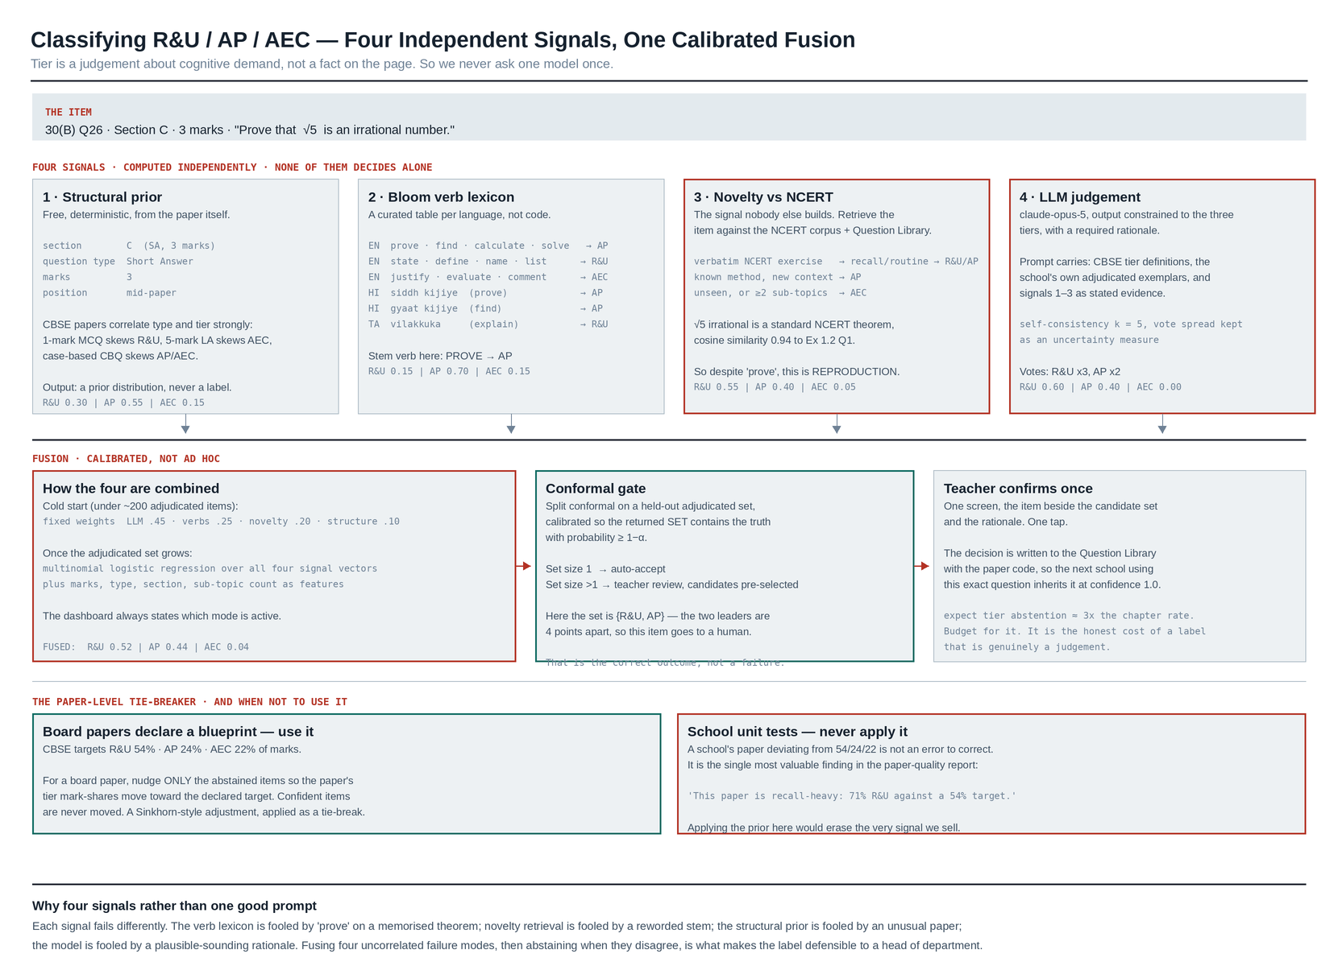
Figure C — the four-signal tier classification ensemble, with a worked example.

Signal 1 — Structural prior (free, deterministic)
Question type, marks, and section position. CBSE papers correlate these with tier strongly: 1-mark MCQs skew R&U, 5-mark LAs skew AEC, 4-mark case-based questions skew AP/AEC. Output is a prior distribution over the three tiers, never a label.

Signal 2 — Bloom verb lexicon (a data table per language)
Tier | English | Hindi | Tamil
R&U | state, define, name, list, identify, recall, choose the correct option, match, what is | बताइए, लिखिए, समझाइए | எழுதுக, விளக்குக
AP | calculate, find, solve, compute, prove, determine, construct, draw, apply, use | ज्ञात कीजिए, सिद्ध कीजिए, हल कीजिए | கண்டறிக, தீர்க்க
AEC | justify, evaluate, analyse, compare and contrast, comment, criticise, suggest, design, in your opinion, give reasons | मूल्यांकन कीजिए, समीक्षा कीजिए, अपने विचार | மதிப்பிடுக, ஆய்க

Curated once per language, versioned as data. Not code, and not a model.

Signal 3 — Novelty against NCERT (the differentiator)
Retrieve the item against the NCERT exercise corpus and the validated Question Library:
- near-verbatim match to an NCERT exercise ⇒ reproduction ⇒ R&U or routine AP
- known method in an unfamiliar context ⇒ AP
- unseen, or spanning ≥ 2 sub-topics in the Q-matrix ⇒ AEC
This is the signal that catches the trap the verb lexicon falls into. "Prove that √5 is an irrational number" carries the verb prove — which reads as AP — but it is a standard NCERT theorem that students memorise, so its real demand is reproduction. Only the retrieval signal knows that.

Signal 4 — LLM judgement, constrained
claude-opus-5, output restricted to the three tiers, with a required rationale. The prompt carries the CBSE tier definitions, the school's own adjudicated exemplars, and signals 1–3 as stated evidence. Self-consistency at k = 5; the vote spread is kept as an uncertainty measure.

Fusion
- Cold start (under ~200 adjudicated items): fixed weights — LLM 0.45, verbs 0.25, novelty 0.20,
structure 0.10.
- Once the adjudicated set grows: multinomial logistic regression over all four signal vectors
plus marks, question type, section and sub-topic count. Fitted on your own adjudicated data.
- The dashboard always states which mode is active.

Abstention
Split conformal prediction on a held-out adjudicated set, calibrated so the returned set contains the truth with probability ≥ 1−α. Set size 1 ⇒ auto-accept. Set size > 1 ⇒ teacher review with the candidates pre-selected. Expect tier abstention at roughly three times the chapter rate. That is the honest cost of a label that is genuinely a judgement, and it should be budgeted, not engineered away.

The paper-level tie-breaker, and when not to use it
CBSE targets R&U 54% / AP 24% / AEC 22% of marks.
- Board paper, blueprint declared: nudge only the abstained items so the paper's tier
mark-shares move toward the target. Confident items are never moved. A Sinkhorn-style adjustment, used strictly as a tie-break.
- School unit test: never apply it. A school paper deviating from 54/24/22 is not an error to
correct — it is the single most valuable line in the paper-quality report ("this paper is recall-heavy: 71% R&U against a 54% target"). Applying the prior there would erase the finding we sell.

Why four signals rather than one good prompt
Each fails differently. The verb lexicon is fooled by prove on a memorised theorem. Novelty retrieval is fooled by a reworded stem. The structural prior is fooled by an unusual paper. The model is fooled by its own plausible rationale. Fusing four uncorrelated failure modes, then abstaining when they disagree, is what makes the label defensible to a head of department.

Validation
Two independent reviewers on the pilot set; report Cohen's κ per level. Target κ ≥ 0.85 chapter, ≥ 0.75 sub-topic, ≥ 0.70 tier. Later, Q-matrix refinement from response data acts as a third, tireless reviewer: items whose response patterns contradict their assigned tier are routed back for review.

4. Mapping to the answer sheet

4.1 Locate
- Ink separation — teacher red, student black/blue. Per-school hue centroids fitted by k-means
on ink pixels from three unlabelled pages; long straight red structures removed first (the printed margin rule).
- Anchors from the student layer. Every one of the eight papers instructs: *"Please write down
the Serial Number of the question in the answer-book at the given place before attempting it."* The anchor is a field the board requires the student to fill in.
- Mark candidates from the teacher layer — isolated and circled numerals; ticks, crosses and
strikes excluded by shape; page and section totals detected separately as extra equations.

4.2 Resolve the address
- Normalise: strip punctuation, map Devanagari and Tamil numerals, fold script variants
(16(b) = Q.16 b = 16 (kha)).
- Closed vocabulary — the parsed address must exist in the frozen Q-matrix. 16(c) does not
exist on this paper, so it is rejected, never invented.
- Section prior — a page inside the Geography block resolves an ambiguous 4 to B/4.
- Monotonicity — addresses should advance down the script; a break is a flag, not a silent
reorder.

4.3 Bind and reconcile
Cost matrix over vertical distance, answer-block containment, side consistency and value plausibility ⇒ Hungarian algorithm (scipy.optimize.linear_sum_assignment). Then refit the teacher's own layout convention from the confident bindings and solve again.
Then the constraint solver:
maximise Σ log p_q(m_q)
subject to Σ marks over the paper = grand total
Σ marks in each section = section total (one equation per section)
Σ marks on each page = page total (where present)
0 ≤ m_q ≤ max_marks(q), on the legal step lattice
Exact dynamic programme. If nothing clears the likelihood floor the script is flagged, not guessed.

4.4 Resolve choice — the rule that protects the diagnosis
For each choice_group_id, the attempted alternative takes the mark. The other is recorded `NOT OFFERED` — a third state, distinct from zero and from absent.
Scoring an unattempted alternative as zero would systematically mark every student weak in whichever topic they chose to avoid, which is the exact inverse of the truth. NOT OFFERED rows are excluded from every denominator and surface as coverage gaps.

4.5 Roll up to the diagnosis
For each student:
earned[skill, tier] = Σ marks on addresses tagged (skill, tier), NOT OFFERED excluded
available[skill, tier] = Σ max_marks on those same addresses
mastery[skill] = G-DINA posterior over the Q-matrix (later; deterministic rates first)
The sub-topic × tier cross-tab is the diagnosis. High R&U with low AP on the same sub-topic is the "knows the formula, cannot apply it" signature — and it is only detectable when the paper actually contains both tiers for that sub-topic. When it does not, the report says so rather than asserting a diagnosis the paper cannot support.
The evidence floor still applies: under 2 marks or 2 questions on a skill, report insufficient_evidence, never a percentage.

5. Stack, by stage
Stage | Tools
Ingest, fingerprint, render | PyMuPDF · FastAPI · S3 (ap-south-1)
Orientation, imposition, dewarp, ink separation, blobs | OpenCV · NumPy · scikit-learn (k-means)
Text detection / printed recognition (assist) | PaddleOCR
Question paper understanding, instructions, addresses | claude-opus-5, structured outputs, strict: true tools, two passes
Skill + tier classification | claude-opus-5 (k=5) + pgvector retrieval + verb lexicon tables + logistic-regression fusion
Handwritten mark crops | claude-haiku-4-5; escalate disagreements to claude-opus-5; Batches API overnight (−50%)
Association | scipy.optimize.linear_sum_assignment
Reconciliation | pure-Python exact DP
Storage | PostgreSQL 16 (+ pgvector, ltree, RLS) · Redis + arq · S3
Analysis, reports | pandas · SciPy · dbt → DuckDB · Jinja2 → WeasyPrint
Training corpus | ml_corpus schema — every prediction with its full distribution, every human label
Frontend | Next.js 15 · TypeScript · Dexie · OpenCV.js · next-intl (EN/TA/HI)
Ops | AWS ap-south-1 · Sentry · OpenTelemetry · GitHub Actions

6. What to build first, given eight papers
- English and Science exercise every mechanism — sections, sub-parts, internal choice, all eight
question types, the verification equations — without imposition or non-Latin script. Prove the pipeline there.
- Then Maths 30(B), which adds 4-up de-imposition and the bilingual parity rule, and whose
printed section arithmetic makes verification trivial to test.
- Then Tamil, which adds 2-up plus 90° rotation plus Tamil script — three new axes at once, on a
short 12-page paper.
- Hindi last — 1-up and structurally simple, but Devanagari handwriting in the answer scripts is
the hardest recognition case, so it benefits most from arriving after the constraint solver is proven.
Each step adds one front-end capability to a pipeline that is already working. None of them requires a new pipeline.

